**AIR530 GPS Module User Manual**

**English Translation of Version 1.7 Dated 18/08/2020**

**Produced by: Https://Securethings.Uk**

**All copyright of the product and Original manual owned by:**  Shanghai Hezhou Communication Technology Co., Ltd.

Contents

Index 1

1. Introduction 1

2. Module performance: 1

3. Module pin assignment: 2

4. Reference design circuit: 2

4.1 Design considerations 3

4.2 GPS antenna 3

5. Module recommended PCB package size diagram 3

6. **NMEA0183** Data protocol 4

6.1 NMEA 0183 in brief 4

6.2 Goke NMEA command 4

6.3 GKC interface data format 4

7. GKC commands 5

7.1. Command: 001 5

7.2 Command: 030 5

7.3 Command: 040 5

7.4 Command: 051 5

7.5Command: 101 5

7.6 Command: 105 5

7.7 Command: 113 6

7.8 Command: 114 6

7.9 Command: 115 6

7.10 Command: 147 6

7.11 Command: 149 7

7.12 Command: 161 7

7.13 Command: 201 7

7.14 Command: 202 7

7.15 Command: 239 7

7.16 Command: 240 7

7.17 Command: 241 7

7.18 Command: 242 8

7.19 Command: 243 8

7.20 Command: 244 8

7.21 Command: 278 8

7.22 Command: 279 8

7.23 Command: 280 8

7.24 Command: 284 9

7.25 Command: 356 9

7.26 Command: 357 9

7.27 Command: 462 9

7.28 Command: 463 9

7.29 Command: 639 9

8. Support NMEA0183 protocol 9

8.1 GGA 10

8.2 GSA 10

8.3 GSV 12

8.4 RMC 13

8.5 VTG 14

9. GNSS tool naviTrack 15

# Introduction

Air530 module is a high-performance, highly integrated multi-mode satellite positioning and navigation module. Small size, low power consumption, can be used for vehicle navigation

Navigation, smart wear, drones and other GNSS positioning applications. Moreover, it provides software and hardware interfaces compatible with other module manufacturers. This greatly reduces the user's development cycle. The module supports GPS/Beidou/GLONASS/Galileo/QZSS/SBAS. Adopt the integrated design of radio frequency baseband, integrate DC/DC, LDO, LNA, RF front-end, baseband processing, 32-bit RISC CPU, RAM, FLASH storage, RTC and power supply Management and other functions. Provide ultra-high performance, even in weak signal places, it can quickly and accurately locate.

# Module performance:

|  |  |  |  |
| --- | --- | --- | --- |
| **Category** | **Index item** | **Typical value** | **Unit** |
| Positioning time [Test  condition 1] | Pure hardware cold start | 27.5 | s |
| Pure hardware hot start | <1 | s |
| Pure hardware recapture | <1 | s |
| Software-assisted A-GNSS (second positioning) | <5 | s |
| Sensitivity  [Test condition 2] | Cold start | -148 | dBm |
| Hot Start | -162 | dBm |
| Recapture | -164 | dBm |
| track | -166 | dBm |
| Precision  [Test condition 3] | Horizontal positioning accuracy | 2.5 | m |
| High positioning accuracy | 3.5 | m |
| Speed ​​​​accuracy | 0.1 | m/s |
| Timing accuracy | 30 | ns |
| Power consumption  [Test condition 4] | Capture current value @3.3v | 42.6 | mA |
| Tracking current value @3.3v | 36.7 | mA |
| Low power mode @3.3V  (Send command: $PGKC051,0) | 0.85 | mA |
| Ultra-low power consumption mode @3.3V  (Send command: $PGKC105,4) | 31 | nA |
| Environment | Operating temperature | -35℃- 85℃ |  |
| Storage temperature | -55℃- 100℃ |  |
| humidity | 5%-95% |  |

Note: The above result is GPS/Beidou dual mode working mode

[Test Condition 1]: The number of receiving satellites is greater than 6, the signal strength of all satellites is -130dBm, and the average value is taken after 10 tests, and the positioning error is less than 10 meters.

[Test condition 2]: The external LNA has a noise figure of 0.8, the number of receiving satellites is greater than 6, and the received signal strength value is locked within five minutes or without losing lock.

[Test condition 3]: Open and unobstructed environment, 24 hours continuous power-on test, 50% CEP.

[Test condition 4]: The number of receiving satellites is greater than 6, and the signal strength of all satellites is -130dBm.

# Module pin assignment:

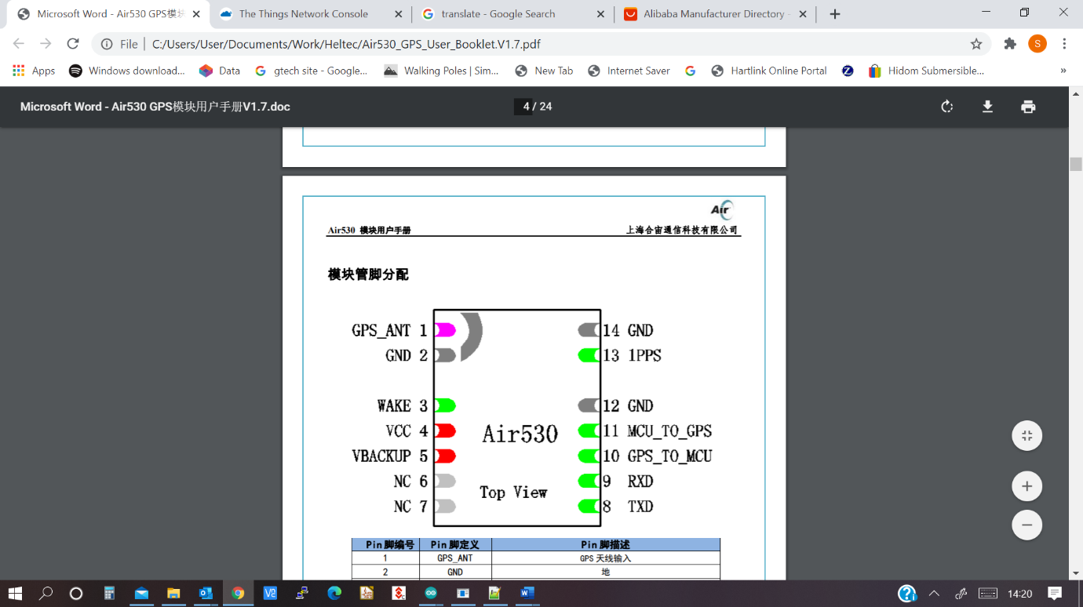The following is the pinout of the device.

|  |  |  |
| --- | --- | --- |
| **Pin No** | **Pin Definition** | **Pin description** |
| 1 | GPS_ANT | GPS antenna input |
| 2 | GND | Ground |
| 3 | WAKE | Input, high effective (2.8V), when the module enters ultra-low power consumption mode, only  Wake up the module by pulling up WAKE |
| 4 | VCC | Main power supply, 2.8V-4.2V |
| 5 | VBACKUP | If you want to support hot start, VBACKUP must be maintained when the module is shut down  The voltage range of the backup battery is 2.8V-3.3V,  VBACKUP must have power supply, otherwise the module will not work; If the backup battery is not connected, please connect VBACKUP and VCC together; |
| 6 | NC | Reserved pins, can be left floating |
| 7 | NC | Reserved pins, can be left floating |
| 8 | TXD | Serial port TX (2.8V), output GPS NMEA0183 data,  The default baud rate is 9600bps |
| 9 | RXD | Serial RX (2.8V) |
| 10 | GPS_TO_MCU | Reserved pins, can be left floating |
| 11 | MCU_TO_GPS | Reserved pins, can be left floating |
| 12 | GND | Ground |
| 13 | 1PPS | One pulse per second (2.8V) |
| 14 | GND | Ground |

# Reference design circuit:

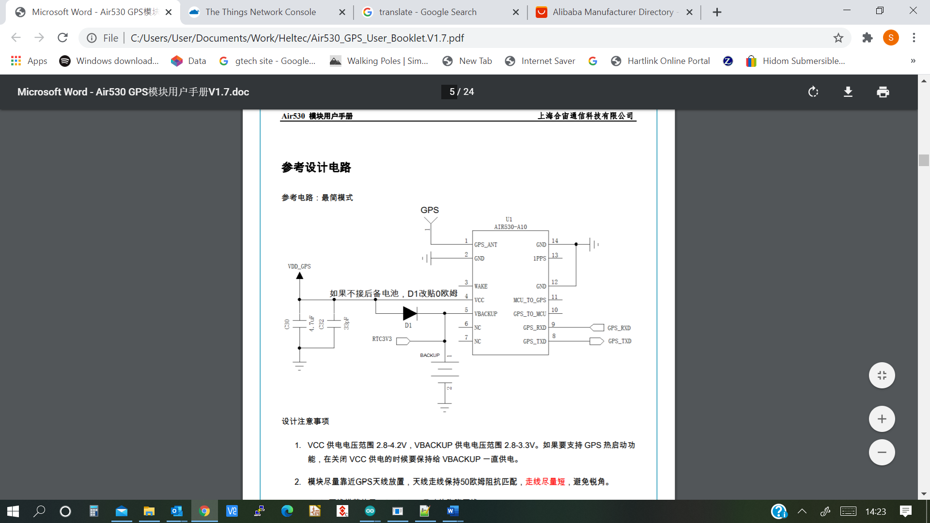

## Design considerations

1. The VCC supply voltage range is 2.8-4.2V, and the VBACKUP supply voltage range is 2.8-3.3V. If you want to support GPS hot start when the VCC power supply is turned off, the VBACKUP must always be supplied with power.

2. Place the module as close as possible to the GPS antenna, keep the antenna trace at 50ohm impedance matching, and keep the trace as short as possible to avoid acute angles.

3. It is recommended to use a ceramic antenna with a size of 25*25*4mm for the GPS antenna.

4. The serial port TXD and RXD are 2.8V TTL level. If connected to a PC, RS232 level conversion is required. Users can use this serial port to receive positioning information data and software upgrades

5. This module is a temperature-sensitive device, and drastic temperature changes will cause its performance to decrease. Try to stay away from high-temperature airflow and high-power during use.

Heating device.

## GPS antenna

GPS antennas can be selected as passive antennas or active antennas according to needs. Active antennas are more effective than passive antennas, but the cost is high.

1. Passive antenna: If a passive antenna is used, it is recommended that the trace between the antenna and the module be as short as possible. The most ideal situation is that the GPS module is directly placed

Place it on the back of the antenna so that there is zero distance between the antenna pad of the module and the GPS antenna feed point, as shown in the following figure:

2. Active antenna: When using an active antenna, pay attention to the power supply voltage range of the active antenna. If the power supply of the active antenna is shared with the power supply of the module

For a power supply, a 47nH inductor needs to be connected in series, and a 1000pF capacitor is connected in parallel near the antenna. There is no need to add an external DC blocking capacitor.

The reference circuit is as follows:

# Module recommended PCB package size diagram

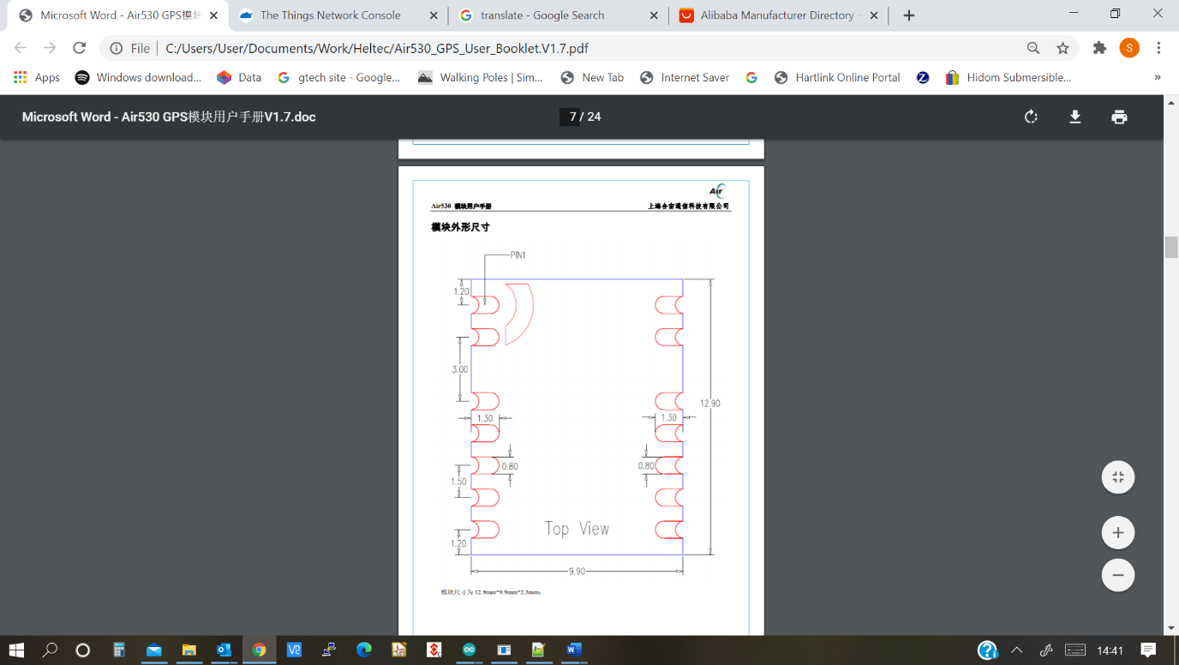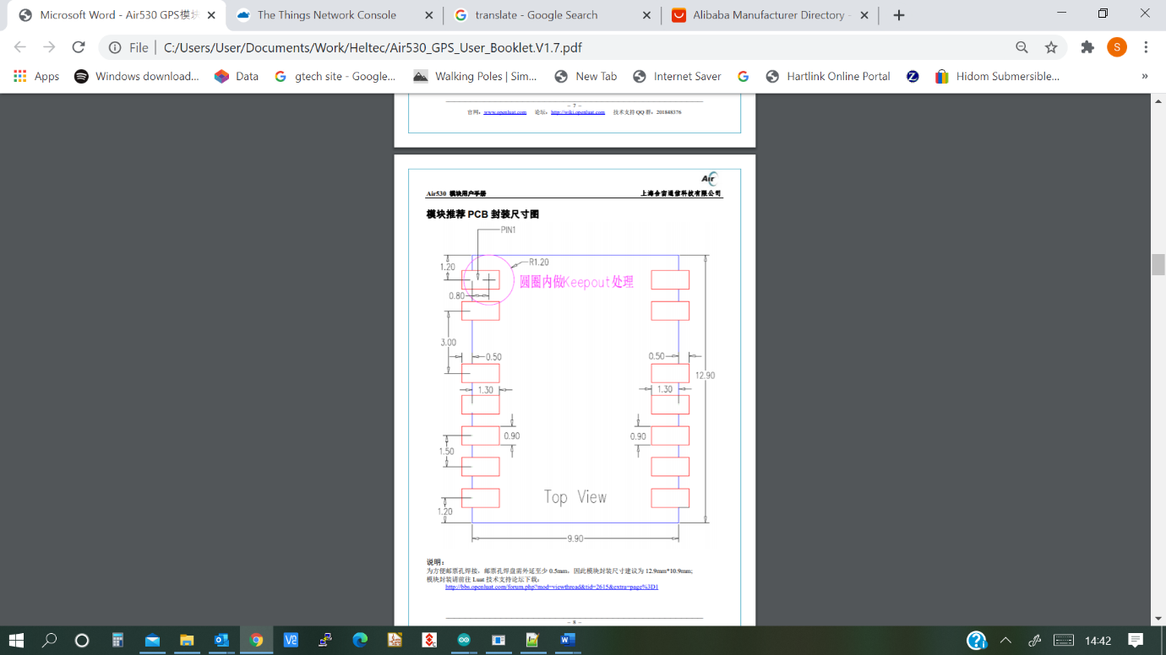

In order to facilitate the soldering of the stamp hole, the stamp hole pad needs to be extended by at least 0.5mm, so the package size of the module is recommended to be 12.9mm*10.9mm*2.3mm; Please go to Luat Technical Support Forum to download the module package: <http://bbs.openluat.com/forum.php?mod=viewthread&tid=2615&extra=page%3D1>

# **NMEA0183** Data protocol

The AIR530 module supports the NMEA 0183 V4.1 protocol and is compatible with previous versions. For more information about NMEA 0183 V4.1, please refer to NMEA 0183 V4.1 official document.

## 6.1 NMEA 0183 in brief

GGA: Time, location, number of satellites

GLL: Longitude, latitude, UTC time

GSA: GPS receiver operating mode, satellites used for positioning, DOP value, positioning status

GSV: Visible GPS satellite information, elevation angle, azimuth angle, signal-to-noise ratio

RMC: Time, date, location, speed

VTG: Ground speed information

## Goke NMEA command

Air530 has customized some commands to control cold, hot, warm start and satellite positioning mode, etc., you can send commands directly through the serial port. To control the module, the command format is as follows:

1. Start command

System hot start command: $PGKC030,1,1*2C<CR><LF>

System warm start command: $PGKC030,2,1*2F<CR><LF>

System cold start command: $PGKC030,3,1*2E<CR><LF>

System reset cold start: $PGKC030,4,1*29<CR><LF>

2. Satellite positioning mode setting

Single GPS: $PGKC115,1,0,0,0*2B<CR><LF>

GPS+BEIDOU: $PGKC115,1,0,1,0*2A<CR><LF>

GPS+GLONASS: $PGKC115,1,1,0,0*2A<CR><LF>

GPS+GALILEO: $PGKC115,1,0,0,1*2A<CR><LF>

## GKC interface data format

The GKC interface is the interface for interaction between the user system and the Air530. The command format is as follows and the CheckSum, this can be calculated by <https://nmeachecksum.eqth.net/> . The command format is as follows:

**$PGKC Command Arguments,*, CheckSum ,CR, LF**

The command number sent is made up of an “Arguments” that Indicates the parameters needed to send the command. There can be multiple parameters. Different commands correspond to different data and refer to the following for specific values. The * indicated the end of the data. The CheckSum: Check data of the entire command the is followed by CR, LF: e.g. Sample data: $PGKC030,3,1*2E <CR><LF>

# 7. GKC commands

## 7.1. Command: 001

Reply message, respond to the message processing result sent by the other party

Arguments:

Arg1: The command of the message that this message answers.

Arg2: "1", the received message is not supported

"2", valid message, but incorrect execution

"3", valid message, and executed correctly

Example:

$PGKC001,101,3*2D<CR><LF>

## 7.2 Command: 030

System restart command

Arguments:

Arg1: "1", hot start

"2", warm start

"3", cold start

Arg2: "1", software restart

Example:

$PGKC030,1,1*2C<CR><LF>

## 7.3 Command: 040

Erase auxiliary positioning data in flash

Arguments: no

Example: $PGKC040*2B<CR><LF>

## 7.4 Command: 051

Enter standby low power consumption mode

Arguments: Arg1: "0", stop mode “1", sleep mode

Example: $PGKC051,1*36<CR><LF>

## 7.5Command: 101

Configure the interval for outputting NMEA messages (in mS)

Arguments: Arg1: 200-10000

Example: $PGKC101,1000*02<CR><LF>

## Command: 105

Enter periodic low power mode

Arguments:

Arg1:

"0", normal operation mode

"1", cycle ultra-low power tracking mode, need to pull up WAKE to wake up

"2", periodic low power consumption mode

"4", directly enter the ultra-low power tracking mode, need to pull up WAKE to wake up

"8", automatic low power consumption mode, can wake up via serial port

"9", automatic ultra-low power tracking mode, need to pull up WAKE to wake up

Arg2: running time (milliseconds), this parameter works in the periodic mode where Arg1 is 1, 2

Arg3: Sleep time (milliseconds), this parameter works in the periodic mode where Arg1 is 1, 2

Example: $PGKC105,8*3F<CR><LF>

## 7.7 Command: 113

Enable or disable QZSS NMEA format output

Arguments: Arg1: "0", close "1", turn on

Example: $PGKC113,1*31<CR><LF>

## Command: 114

Turn QZSS function on or off

Arguments: Arg1: "0", turn on "1", close

Example: $PGKC114,0*37<CR><LF>

## 7.9 Command: 115

It is noted that this command when tested did not behave as the manufactures specification and failed to Generate “GA” messages when used as a single setting or combined with GPS to detect **GALILEO GNSS and from testing this is a function that does not work.** This is does not comply with the setting process**. It is also worth noting that the Air530 can only support 2 GNSS system and not 4 as expected**. So, based on testing for Europe then the settings that give the most satellites visible and hence accuracy, is with GPS and GLONASS set for the search mode.

Arguments:

Arg1: "1", GPS on

"0", GPS off

Arg2: "1", Glonass on

"0", Glonass off

Arg3: "1", Beidou on

"0", Beidou off

Arg4: "1", Galileo on

"0", Galileo off

Example: $PGKC115,1,0,0,0*2B<CR><LF>

## Command: 147

Set NMEA output baud rate

Arguments:

Arg1: 9600, 19200, 38400, 57600, 115200...921600.

Example: $PGKC147,115200*06<CR><LF>

Or: $PGKC147,57600*35<CR><LF>

## Command: 149

Set NMEA serial port parameters

Arguments:

Arg1: "0", NMEA data “1", Binary data

Arg2: 9600, 19200, 38400, 57600, 115200...921600.

Example: $PGKC149,0,38400*2C<CR><LF>

## Command: 161

PPS settings

Arguments:

Arg1: "0", turn off PPS output

"1", the first fix

"2", 3D fix

"3", 2D/3D fix

"4", always on

Arg2: PPS pulse width (mS)

Requires less than 999

Arg3: PPS period (mS) Requires greater than PPS pulse width

Example: $PGKC161,2,500,1000*

2E<CR><LF>

## Command: 201

Query the interval of NMEA messages

Arguments:

no

Example:

$PGKC201*2C<CR><LF>

## Command: 202

Return interval of NMEA message (response to 201 command)

Arguments:

no

Example:

$PGKC202,1000,0,0,0,0*02<CR><LF>

## Command: 239

Turn SBAS function on or off

Arguments:

Arg1: "0", turn on “1", close

Example: $PGKC239,1*3A<CR><LF>

## Command: 240

Query whether SBAS is enabled

Arguments: no

Example: $PGKC240*29<CR><LF>

## Command: 241

Return whether SBAS is enabled (response 240 command)

Arguments:

Arg1: "0", close "1", open

Example: $PGKC241,1*35<CR><LF>

## Command: 242

Set NMEA sentence output enable

Arguments:

Arg1: GLL "0", close; "1", open

Arg2: RMC "0", close; "1", open

Arg3: VTG "0", close; "1", open

Arg4: GGA "0", close; "1", open

Arg5: GSA "0", close; "1", open

Arg6: GSV "0", close; "1", open

Arg7: GRS "0", close; "1", open

Arg8: GST "0", close; "1", open

Arg9~ Arg19: reserved

Example: $PGKC242,1,1,1,1,1,1,0,0,0,0,0,0,0,0,0,0,0,0,0*37 <CR><LF>

## Command: 243

Query output frequency of NMEA sentences

Arguments: no

Example: $PGKC243*2A<CR><LF>

## Command: 244

Returns the output frequency of NMEA sentences (response to the 243 command)

Arguments: Args: Refer to 242 command

Example: $PGKC244,1,1,1,1,1,1,0,0,0,0,0,0,0,0,0,0,0,0,0*31<CR><LF>

## Command: 278

Set RTC time

Arguments:

Arg1: year

Arg2: Month, 1~12

Arg3: day, 1~31

Arg4: Hour, 0~23

Arg5: minutes, 0~59

Arg6: seconds, 0~59

Example: $PGKC278,2017,3,15,12,0,0*12<CR><LF>

## Command: 279

Query RTC time

Arguments: no

Example: $PGKC279*23<CR><LF>

## Command: 280

Returns the output frequency of NMEA sentences (response to the 243 command)

Arguments: Args: Refer to the 278 command

Example: $PGKC280,2017,3,15,12,0,0*15<CR><LF>

## Command: 284

Set the speed threshold, when the speed is lower than the threshold, the output speed is 0

Arguments: Arg1: Threshold

Example: $PGKC284,0.5*26<CR><LF>

## Command: 356

Set the HDOP threshold, when the actual HDOP is greater than the threshold, no positioning

Arguments: Arg1: Threshold

Example: $PGKC356,0.7*2A<CR><LF>

## Command: 357

Get HDOP threshold

Arguments: no

Example: $PGKC357*2E<CR><LF>

## Command: 462

Query the version number of the current software

Arguments: no

Example: $PGKC462*2F<CR><LF>

## Command: 463

Return the version number of the current software (response to 462 command)

Arguments: no

Example: $PGKC463,GOKE9501_1.3_17101100*22<CR><LF>

## Command: 639

Set approximate location information and time information to speed up positioning

Arguments:

Arg1: Latitude, for example: 28.166450

Arg2: Longitude, for example: 120.389700

Arg3: height, for example: 0

Arg4: year

Arg5: month

Arg6: day

Arg7: When the time is UTC time

Arg8: points

Arg9: seconds

Example: $PGKC639,28.166450,120.389700,0,2017,3,15,12,0,0*33<CR><LF>

# 8. Support NMEA0183 protocol

Air530 supports the NMEA0183 V4.1 protocol and is compatible with previous versions. The detailed information about NMEA0183 V4.1 from the official document. Common output formats are as follows:

* GGA: time, location, number of satellites
* GSA: GPS receiver operating mode, satellites used for positioning, DOP value, positioning status
* GSV: visible GPS satellite information, elevation angle, azimuth angle, signal-to-noise ratio
* RMC: time, date, location, speed
* VTG: Ground speed information

Statement Identifier Meaning:

* BD BDS, Beidou Second Generation Satellite System
* GP GPS
* GL GLONASS
* GA Galileo
* GN GNSS, Global Navigation Satellite System

## GGA

$--GGA,hhmmss.ss,llll.ll,a,yyyyy.yy,a,x,xx,xx,xx,M,xx,M,xx,xxxx*hh

Sample data: $GPGGA,065545.789,2109.9551,N,12023.4047,E,1,9,0.85,18.1,M,8.0,M,,*5E

|  |  |  |  |
| --- | --- | --- | --- |
| Name | Sample unit | Units | description |
| Message ID | $GPGGA |  | GGA protocol header |
| UTC time | 065545.789 |  | hhmmss.sss |
| Latitude | 2109.9551 |  | ddmm.mmmm |
| N/S indication | N |  | N=North, S=South |
| Longitude | 12023.4047 |  | dddmm.mmmm |
| E/W indication | E |  | W=West, E=East |
| Positioning instructions | 1 |  | 0: not positioned 1  1: SPS mode, positioning is valid  2: Differential, SPS mode, positioning is valid  3: PPS mode, positioning is valid |
| Number of satellites | 9 |  | Range 0 to 12 ( Seams to go over this limit) |
| HDOP | 0.85 |  | Horizontal accuracy |
| Mean Sea Level | 18.1 | M | Earth is -2.2 M |
| Differential time | 8.0 | s | When there is no DGPS, invalid |
| Differential ID | 0000 |  | If DGPS used |
| Checksum | * 5E |  | Calculated with an NEMA check sum calculator |
| <CR><LF> |  |  | End of message |

## GSA

Sample form $--GSA,a,a,x,x,x,x,x,x,x,x,x,x,x,x,x,x,xx,xx,xx*hh

Sample data: $GPGSA,A,3,10,24,12,32,25,21,15,20,31,,,,1.25,0.85,0.91*04

|  |  |  |  |
| --- | --- | --- | --- |
| Name | Sample | Unit | Description |
| Message ID | $GPGS | GSA protocol header |  |
| Mode 1 | A |  | M=Manual, forced in 2D or 3D mode  A=Auto |
| Mode 2 | 3 |  | 1: Invalid positioning  2: 2D positioning  3: 3D positioning |
| Satellite use | 10 |  | Channel 1 |
| Satellite use | 24 |  | Channel 2 |
| Satellite use | 12 |  | Channel 3 |
| Satellite use | 32 |  | Channel 4 |
| Satellite use | 25 |  | Channel 5 |
| Satellite use | 21 |  | Channel 6 |
| Satellite use | 15 |  | Channel 7 |
| Satellite use | 20 |  | Channel 8 |
| ,,, | ,,, | ,,, | ,,, |
| Satellite use |  |  | Channel 12 |
| PDOP | 1.25 |  | Position accuracy |
| HDOP | 0.85 |  | Horizontal accuracy |
| VDOP | 0.91 |  | Vertical accuracy |
| Checksum | *04 |  |  |
| <CR><LF> |  |  | End of message |

## GSV

Format $--GSV,x,x,x,x,x,x,x,...*hh

Sample data:

$GPGSV,3,1,12,14,75,001,31,32,67,111,38,31,57,331,33,26,47,221,20*73

$GPGSV,3,2,12,25,38,041,29,29,30,097,32,193,26,176,35,22,23,301,30*47

$GPGSV,3,3,12,10,20,185,28,44,20,250,,16,17,217,21,03,14,315,*7D

The following is one lines worth of the GSV data can be up to 4 lines (12 Satellites)

|  |  |  |  |
| --- | --- | --- | --- |
| Name | Sample | unit | description |
| Message ID | $GPGSV |  | GSV protocol header |
| Number of messages | 3 |  | Range 1 to 3 |
| Message number | 1 |  | Range 1 to 3 |
| Number of satellites | 12 |  |  |
| Satellite ID | 14 |  | Range 1 to 32 |
| Elevation | 75 | degree | Up to 90° |
| Azimuth | 001 | degree | Range 0 to 359° |
| Carrier to noise ratio (C/No) | 31 | dBHz | Range 0 to 99, empty when there is no tracking |
| Satellite ID | 32 |  | Range 1 to 32 |
| Elevation | 67 | degree | Up to 90° |
| Azimuth | 111 | degree | Range 0 to 359° |
| Carrier to noise ratio (C/No) | 38 | dBHz | Range 0 to 99, empty when there is no tracking |
| Satellite ID | 31 |  | Range 1 to 32 |
| Elevation | 57 | degree | Up to 90° |
| Azimuth | 331 | degree | Range 0 to 359° |
| Carrier to noise ratio (C/No) | 33 | dBHz | Range 0 to 99, empty when there is no tracking |
| Satellite ID | 26 |  | Range 1 to 32 |
| Elevation | 47 | degree | Up to 90° |
| Azimuth | 221 | degree | Range 0 to 359° |
| Carrier to noise ratio (C/No) | 20 | dBHz | Range 0 to 99, empty when there is no tracking |
| Checksum | *73 |  |  |
| <CR><LF |  |  | > End of message |

## RMC

Format: $--RMC,hhmmss.ss,A,llll.ll,a,yyyyy.yy,a,xx,xx,xxxx,xx,a*hh

Sample data: $GPRMC,100646.000,A,3109.9704,N,12123.4219,E,0.257,335.62,291216,,,A*59

|  |  |  |  |
| --- | --- | --- | --- |
| name | Sample | unit | description |
| Message ID | $GPRMC |  | RMC protocol header |
| UTC time | 100646.000 |  | hhmmss.ss |
| status | A |  | A=Data is valid; V=Data is invalid |
| latitude | 2109.9704 |  | ddmm.mmmm |
| N/S indication | N |  | N=North, S=South |
| longitude | 11123.4219 |  | dddmm.mmmm |
| E/W indication | E |  | W=West, E=East |
| Ground speed | 0.257 | Knot (section) |  |
| position | 335.62 | degree |  |
| date | 291216 | ddmmyy |  |
| Magnetic variable |  |  |  |
| Checksum | *59 |  |  |
| <CR><LF> |  |  | End of message |

## VTG

Sample Format $--VTG,xx,T,xx,M,xx,N,xx,K*hh

Sample data: $GPVTG,335.62,T,,M,0.257,N,0.477,K,A*38

|  |  |  |  |
| --- | --- | --- | --- |
| Name | Sample | Units | description |
| Message ID | $GPVTG |  | VTG protocol header |
| Position | 335.62 | degree |  |
| Reference | T |  | True |
| Position | 335.62 | degree | reference |
| Unit | M |  | Magnetic |
| Speed | 0.257 | Knot |  |
| Unit | N |  | Section |
| Speed | 0.477 | Km/h |  |
| Unit | K | Km/h |  |
| Positioning system mode indication: | A |  | A—Autonomous mode;  D—Differential mode;  E—Estimation (dead reckoning) mode;  M—Manual input mode;  S—simulator mode;  N—The data is invalid. |
| Checksum | *10 |  |  |

# 9. GNSS tool naviTrack

The naviTrack is a GNSS tool specially developed for Air530. It provides users with an easy-to-use,

Powerful visual PC-side tools. Other tools such as u-Center and PowerGPS can also be used.

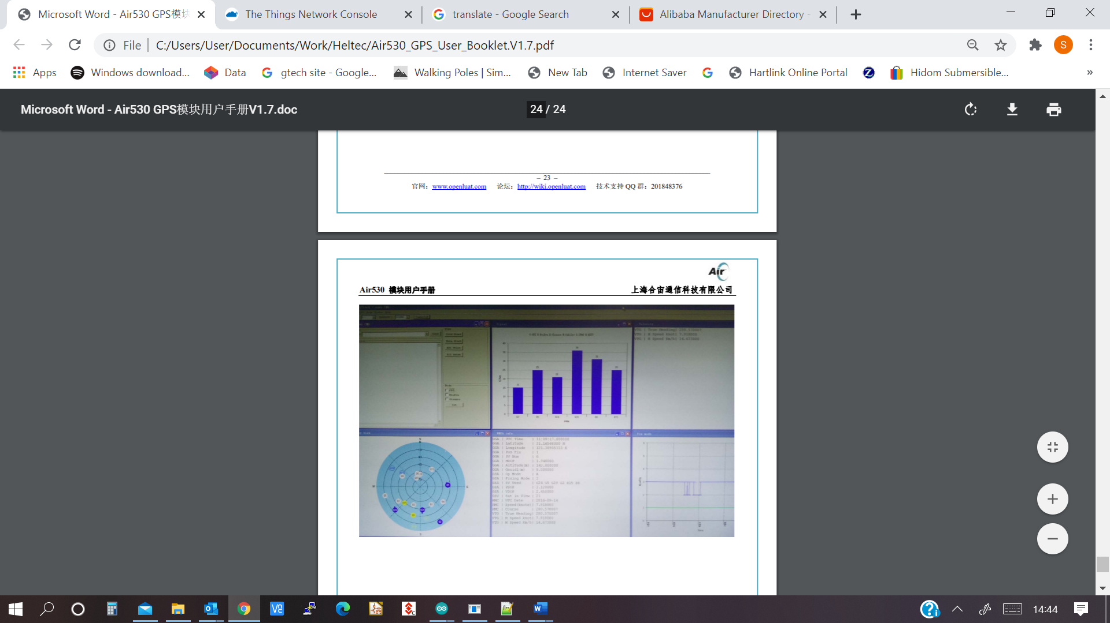

END OF DOCUMENT

18/8/2020